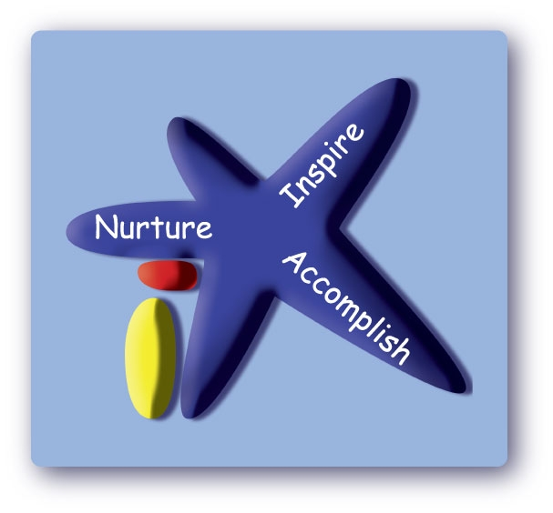
Victoria Road Primary School Victoria Road, Northwich, Cheshire, CW9 5RE
Tel: 01606 663061
Email: admin@victoriaroad.cheshire.sch.uk
Head of School: Mrs Sue Minor

30 July 2026

To Parents & Carers
Relationship and Health Education (RHE) is statutory and forms a part of the Personal, Social, Health and Economic (PSHE) subject. All schools in England are required to teach RHE in primary schools and the ‘Department for Education’ recommends that schools consider teaching Sex Education.
Parents and Carers do not have the right to withdraw their children from lessons that cover the statutory Health and Relationship objectives (this includes puberty lessons) and lessons that cover national curriculum science objectives, including content on human development and reproduction.
To support the delivery of PSHE and RHE, our school has adopted a quality-assured programme called 1decision which has been kitemarked by the PSHE Association - the UK's governing body for the subject area. The 1decision resources have been created by PSHE and Safeguarding experts, together with schools, and most importantly children.
As a part of our curriculum our school chooses to deliver the Sex Education element. This content is delivered in year 6 and is taught through 1decision’s conception topic. Parents and carers can choose to withdraw their child from this unit.
To assist you in your decision, we want to assure you that our curriculum is taught in an age-appropriate manner and provides pupils with the time to ask questions in a safe environment and ultimately receive information based on facts, rather than hearing content second-hand or via online platforms.
To find out more about our chosen provider, we would like to signpost you to their Parent/Carer zone on the 1decision website https://www.1decision.co.uk/resources/parent-carer-zone
where you can review the following:
- What is 1decision?
- How will my child’s school use the 1decision resources?
- What themes do 1decision cover?
- 1decision content overview (including examples of their puberty and conception animations)
- Examples of 1decision Early Years content
- Understanding RSHE document
- Free home activities and much more! Parent/carer Zone:
We hope you will take the time to review this information. Following this, please make an appointment with me via the office if you have any further questions or concerns.
Mrs Sue Minor
Head of School

