EYFS Teacher –Temporary (2 terms with possibility of being made permanent) – 32.44 hours per week. £30,000 - £46,525 (MPS 1 – UPS3).

Victoria Road Primary School are looking to appoint an EYFS Teacher to work in our school. The successful candidate will be a high-quality classroom teacher who enjoys working as part of a small team and is willing to adapt to the varying needs of the school at any given time.
We are looking for a teacher who has a desire and the drive to not only be an outstanding classroom practitioner but also contribute to the wider life of the school to improve opportunities for our pupils. To be successful, you will be well organised, motivated, resilient and flexible with high expectations of attainment, achievement and behaviour and have the drive to make a difference to the education of all our pupils. You will have excellent communication and organisation skills.

We are a friendly, inclusive school and were recently judged to be a good school by Ofsted (May 2024). We are looking for someone who is passionate about children and learning to join our nurturing team.

We are a member of The Aspire Multi Academy Trust and offer a mutually supportive ethos with excellent opportunities for professional development. We are proud to be a Disability Confident Committed Employer, we strongly encourage applications from all persons with a known disability. We aim to ensure a fully inclusive and accessible recruitment process.

If you request any support or have any questions, please contact
Name: Megan Margeson
Phone: 01606663061
Email: bursar@victoriaroad.cheshire.sch.uk

As a Trust we are committed to safeguarding and promoting the welfare of our children. For all shortlisted candidates reference checks and online searches will be completed prior to interview. All successful candidates are subject to satisfactory references, medical checks, right to work in UK and safeguarding checks (including enhanced DBS and a declaration of disqualification (Childcare Disqualification regulations 2009).
If you are committed to helping children thrive and getting the best start in life, then we look forward to hearing from you.

Opportunity to visit the school for a tour: Tuesday 8th October 9.15am or 4pm. Friday 11th October 9.15am or 4pm.
Closing Date: Friday 18th October 12 noon.
Interview: Tuesday 22ND October pm.
Start Date: January 2025
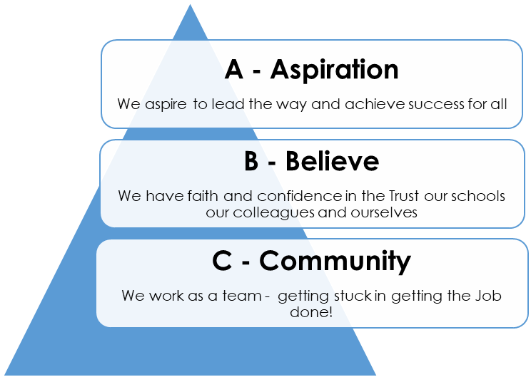
Please return email to: bursar@victoriaroad.cheshire.sch.uk

