Teaching Assistant – Grade 6 including class cover - Temporary – 33.5 hours per week. Grade 6 £25,979 - £28,770 pro rata.
Actual salary £19,687 - £21,802
Victoria Road Primary School are looking to appoint a Grade 6 Teaching Assistant to work in our school. We are looking for an individual to support the teaching staff and work with the other support staff to enhance the development and education of pupils in accordance with the aims and policies of the school. Also, deputise in the absence of a teacher and conduct whole class lessons within an appropriate system of supervision by a qualified teacher which is not necessarily in the same classroom.

We are a friendly, inclusive school and were recently judged to be a good school by Ofsted (May 2024). We are looking for someone who is passionate about children and learning to join our nurturing team.

We are a member of The Aspire Multi Academy Trust and offer a mutually supportive ethos with excellent opportunities for professional development. We are proud to be a Disability Confident Committed Employer, we strongly encourage applications from all persons with a known disability. We aim to ensure a fully inclusive and accessible recruitment process.

If you request any support or have any questions, please contact
Name: Megan Margeson
Phone: 01606663061
Email: bursar@victoriaroad.cheshire.sch.uk

As a Trust we are committed to safeguarding and promoting the welfare of our children. For all shortlisted candidates reference checks and online searches will be completed prior to interview. All successful candidates are subject to satisfactory references, medical checks, right to work in UK and safeguarding checks (including enhanced DBS and a declaration of disqualification (Childcare Disqualification regulations 2009).
If you are committed to helping children thrive and getting the best start in life, then we look forward to hearing from you.

Closing Date: Monday 23rd September 2024 12pm.
Interview: Tuesday 24th September & Wednesday 25th September 2025
Start Date: November 2024
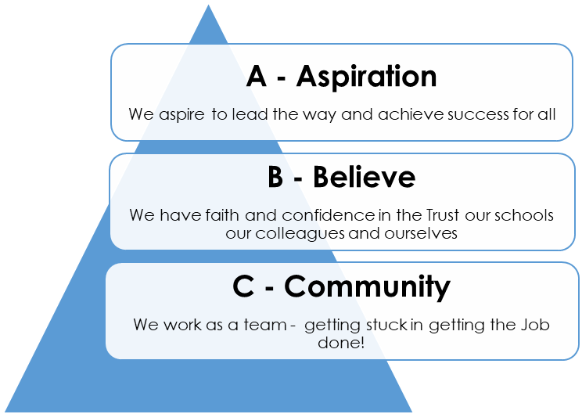
Please return email to: bursar@victoriaroad.cheshire.sch.uk

