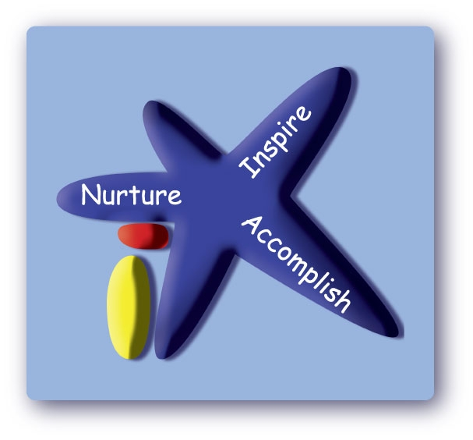
Victoria Road Primary School Victoria Road, Northwich, Cheshire, CW9 5RE
Tel: 01606 663061
Email: admin@victoriaroad.cheshire.sch.uk
Head of School: Mrs Sue Minor

31 July 2026

Dear Year 6 parents and carers

We would like to share the news that Miss C Chesters has secured a promotion at another school. Her last day with Victoria Road Primary School will be on Tuesday 30th April 2024. Whilst we think this is an amazing opportunity for Miss C Chesters we are very sad to be losing her from our school.

From Wednesday 1st May 2024, Mrs J Dodd will take over the year 3/4 class. Mrs D Jones has agreed to teach the year 6 class full time for the rest of the year.

We have shared this news with the children in the class today so they may wish to discuss this further with you this evening.

Please contact us if you have any questions.

Yours Faithfully
Mrs Sue Minor
Head of School

