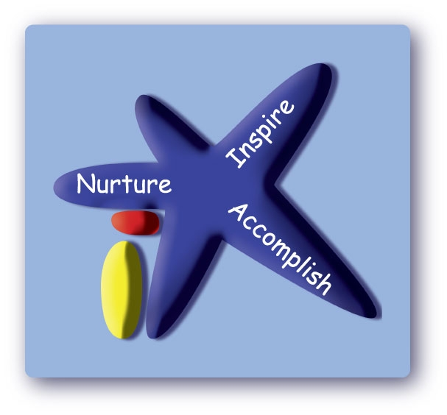
Victoria Road Primary School Victoria Road, Northwich, Cheshire, CW9 5RE
Tel: 01606 663061
Email: admin@victoriaroad.cheshire.sch.uk
Head of School: Mrs Sue Minor

31 July 2026

Dear Year 3/4 parents and carers

We would like to share the news that Miss C Chesters has secured a promotion at another school. Her last day with Victoria Road Primary School will be on Tuesday 30th April 2024. Whilst we think this is an amazing opportunity for Miss C Chesters we are very sad to be losing her from our school.

We have shared this news with the children in the class today so they may wish to discuss this further with you this evening.

We understand that this will raise some questions about the rest of this academic year, we have worked hard to try and provide the best solution for continuity and your child’s wellbeing.

Therefore, we are delighted to tell you that Mrs J Dodd will take over the class from Wednesday 1st May 2024. She has taught your children every Wednesday afternoon since September 2023 and is familiar with the class and the school. Mrs N Rudd will continue to teach the class one day a week (Thursdays).

Mrs Dodd and Miss Chesters have time planned to work together prior to the change. This will ensure the smoothest transition possible.

I hope you will join us in wishing Miss Chesters well. Please contact us if you have any questions.

Yours Faithfully
Mrs Sue Minor
Head of School

